Comparison between:
mad8, madx, ptc & tracking
for the TT2/TT10 transferline with skew quadrupoles.

Madx generates wrong results for the TT2/TT10 transfer line, with skew quadrupoles. This was confirmed with the optics for the continuous transfer (CT), which is used for transporting protons from the PS to the SPS:

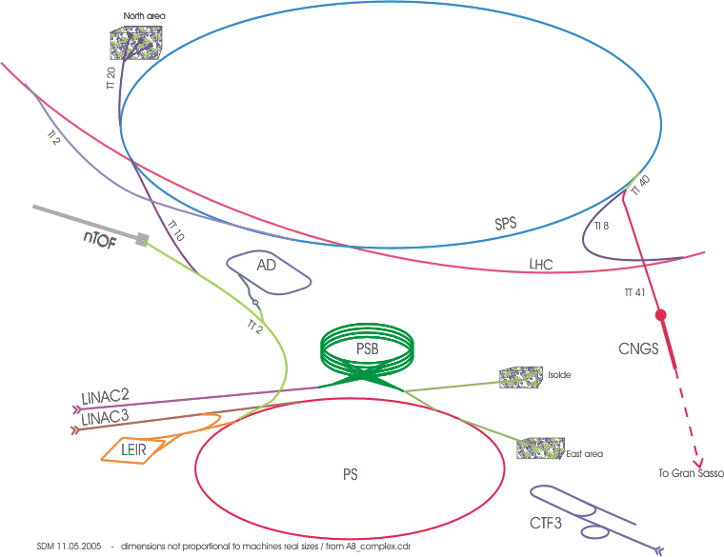

The problem is in the part which does the emittance exchange. This consists of three skew quadrupoles and 4 normal quadrupoles.
The principle of plane exchange
(and emittance exchange)

A complete phase plane exchange requires a transformation of the form:

$$\left(\begin{matrix}x_{1} \\ x_{1}^{'} \\ y_{1} \\ y_{1}^{'}\end{matrix}\right)=\left(\begin{matrix}0 & 0 & m_{\text{13}} & m_{\text{14}} \\ 0 & 0 & m_{\text{23}} & m_{\text{24}} \\ m_{\text{31}} & m_{\text{32}} & 0 & 0 \\ m_{\text{41}} & m_{\text{42}} & 0 & 0\end{matrix}\right)⋅\left(\begin{matrix}x_{0} \\ x_{0}^{'} \\ y_{0} \\ y_{0}^{'}\end{matrix}\right)$$

The thin lens matrix for a skew quadrupole with a $\frac{π}{4}$ turn, the normal quadrupoles and drift space is:
$M_{S}=\left(\begin{matrix}1 & 0 & 0 & 0 \\ 0 & 1 & 1\text{fS} & 0 \\ 0 & 0 & 1 & 0 \\ 1\text{fS} & 0 & 0 & 1\end{matrix}\right)$$M_{F}=\left(\begin{matrix}1 & 0 & 0 & 0 \\ −1f & 1 & 0 & 0 \\ 0 & 0 & 1 & 0 \\ 0 & 0 & 1f & 1\end{matrix}\right)$$M_{Q}=\left(\begin{matrix}1 & 0 & 0 & 0 \\ 1f & 1 & 0 & 0 \\ 0 & 0 & 1 & 0 \\ 0 & 0 & −1f & 1\end{matrix}\right)$$M_{L}=\left(\begin{matrix}1 & L & 0 & 0 \\ 0 & 1 & 0 & 0 \\ 0 & 0 & 1 & L \\ 0 & 0 & 0 & 1\end{matrix}\right)$

CELL=MS.ML.MF.M2L.MD.ML.MS.ML.MF.M2L.MD.ML.MS;
Solve[CELL[[1,1]]=0&&CELL[[1,2]]=0&&CELL[[2,1]]=0&&CELL[[2,2]]=0
&&CELL[[3,3]]=0&&CELL[[3,4]]=0&&CELL[[4,3]]=0&&CELL[[4,4]]=0,{f,fS}] gives:
{{fS=-3L, f=-$\sqrt{2}⋅L$}, {fS=-3L, f=$\sqrt{2}⋅L$}, {fS=3L, f=-$\sqrt{2}⋅L$}, {fS=3L, f=-$\sqrt{2}⋅L$}}

Using a setup of three skew quadrupoles and 4 normal quadrupoles, generates the desired plane exchange:
Q_{S}
Q_{S}
Q_{S}
Q_{D}
Q_{F}
Q_{D}
Q_{F}
2L
2L
L
L
L
L

The layout of the emittance exchange in TT10 is:

qisk.100637 : qisk1006m.f , at = 137.29668;
15.4038
qid.100700 : qid1007m.f , at = 152.70048;
30.2480
qif.100800 : qif1008m.f , at = 182.94848;
14.2097
qisk.100835 : qisk1006m.f , at = 197.15818;
16.0383
qid.100900 : qid1007m.f , at = 213.19648;
30.2480
qif.101000 : qif1008m.f , at = 243.44448;
14.4121
qisk.101036 : qisk1006m.f , at = 257.85658;

Method of calculation

Four different calculations were used: mad8, madx, ptc and tracking with madx:

alfx, betx
MADX
{{x1,px1},
{x2,px2},
{x3,px3}
………
{xn,pxn}}
{{y1,py1},
{y2,py2},
{y3,py3}
………
{yn,pyn}}
alfy, bety
alfy, bety
PTC
alfx, betx
alfy, bety
MADX
alfx, betx
alfy, bety
MAD8
alfx, betx
MADX

The transformation from the list of points in phase-space {{y1,py1}, {y2,py2}, {y3,py3}…. {yn,pyn} } to the set {alfy, bety}, was done in Mathematica.

Results

The initial values for alfx and betx were:
ALFX0 := -2.181915015426;
BETX0 := 25.877037785092;
EMIT0 = 3.07E-7

The initial values of alfy and bety were: ALFY0 := 0.848701065867 ;
and BETY0 := 10.114441818182; They are without importance for our test, because they determine the optical parameters in the horizontal phase-space at the end of TT2/TT10. Our test investigated the vertical parameters at the end of TT2/TT10. However, the values of ALFY0 and BETY0 do change the results in PTC, but to less than 1%o.

 | MADX | MAD8 | PTC | TRACKING
ALFY | 1.19278 | -1.23837 | -1.25136 | -1.25136
BETY | -47.82210 | 42.57078 | 43.09726 | 43.09726

In addition, for the TRACKING example the initial emittance was EMIT0(HOR) = 3.07E-7 and the resulting emittance at the end of the line – in the vertical plane – was EMIT (VER) = 3.070000059956727e-7.

Analysis

MADX and MAD8 do not give the same results for the TT2/TT10 transferline, when the optics contains skew quadrupoles. As soon as MADX encounters the skew quadrupoles:

QISK1006M.F : QUADRUPOLE, L=.5, K1 := KQISK1006M, TILT=-PI/4;

the calculations starts deviating. After the QISKs the optics functions oscillates wildly in MADX. When they finally settle, the betafunctions becomes negative, which is unphysical.

MAD8, PTC and TRACKING give the same results. PTC and TRACKING are similar to within 10⁻⁶ while MAD8 is only precise to 1%.

The alfa and beta values from PTC are really ALFA21 and BETA21. These are coupled values, while ALFA11, BETA11 and ALFA22, BETA22 corresponds to uncoupled motion. However, the coupling at the end of the TT10 line is so small, that we can consider the motion as uncoupled.

Conclusion

- Matching with the TT2/TT10 line should be done with PTC. (The matching is in fact done with madx, but using the ptc_twiss command instead of twiss: http://project-ps-optics.web.cern.ch/project-PS-optics/cps/TransLines/PS-SPS/2007/2007_ct.madxptc )
- MADX and MAD8 give different results for the TT2/TT10 line.
- MADX seems not to handle skew quadrupoles correctly. Are there other problems than for TT2/TT10?

The tracking is not done with the TRACK command, but twiss transformations from {x,px} to {y,py}

