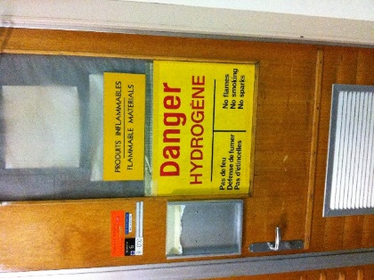
EMERGENCY ACTIONS FOR
ROOM 6/R-010
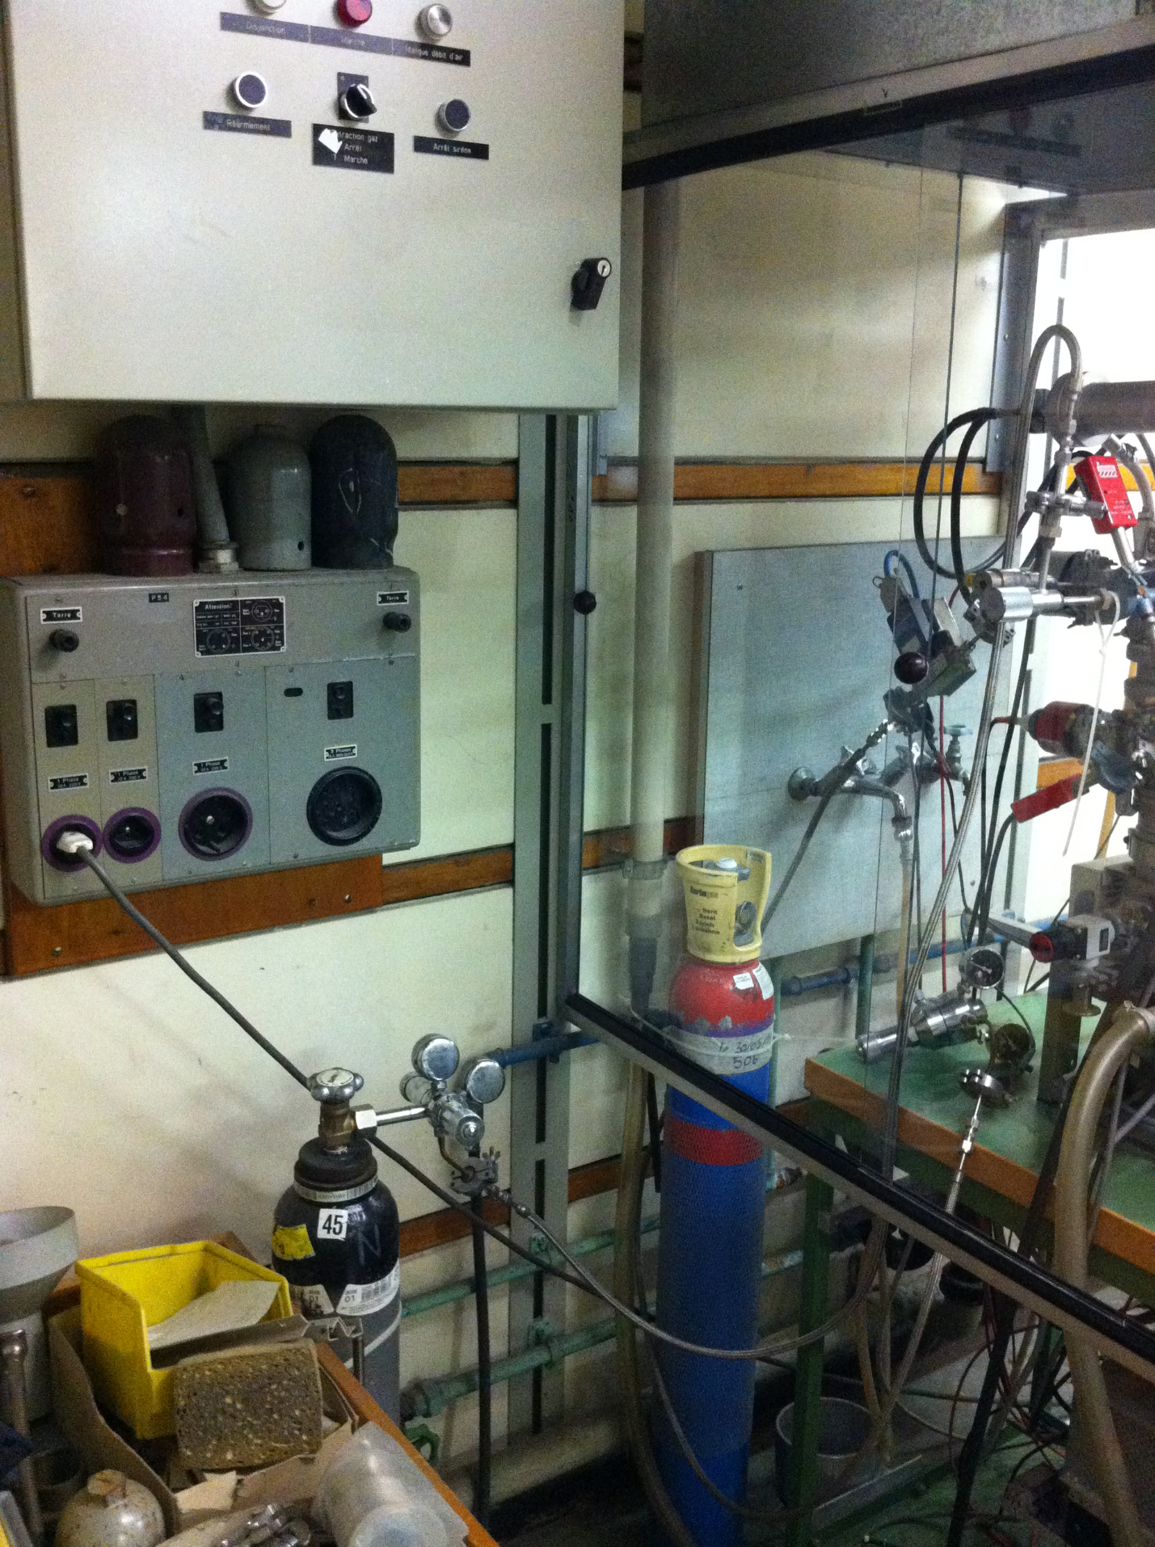

Turn off the hydrogen gas
Switch off the power

