Henry Ohlin
July 16^{th,} 2014

My Two-Week Traineeship at CERN

Over the summer, I visited family in Switzerland. I had a great time with my family but that was not the only reason I visited. Earlier in the year my grandmother had wonderfully setup an opportunity for me to work for a man named Olav Berrig, who is a very good friend of my grandparents. Olav works at CERN, the particle physics headquarters of the world. My job, known as a traineeship, was to attend university level lectures in the mornings, and then in the afternoon, I was to work with Olav. In the first week, I was taught how to use a network analyzer as well as many formulas that will be helpful to understand physics, which I am set to take in the upcoming school year. In the second week, Olav and I worked with Japanese university students to measure Q factor in order to maximize the energy transfer from the RF coil to the hydrogen plasma. The hydrogen plasma is used to produce proton beams, by stripping off the electrons. The text below reflects what I have learned from my experience.

What is CERN?

CERN is known as European council for nuclear research. The acronym CERN came from the French (Organisation Européen pour la Recherche Nucléaire). CERN is located on the Franco-Swiss border in Meyrin, Geneva, Switzerland. CERN was established in 1954, and is a European research facility for particle physics. CERN has twenty-one member nations, and seven other nations have observer status, including the United States. CERN’s job is to provide the accelerators, magnets and many other materials, so that universities may use the facility for experiments.

CERN’s Best Accomplishments

1983- In the UA1 and UA2 experiments, CERN verified the theory of the weak nuclear force, by discovering the W and Z bosons.

1991- The World Wide Web originally started as a CERN project called ENQUIRE which sought a way for fellow researchers to communicate with one another. The World Wide Web was created when the first webpage went online in 1991.

1995- In the PS210 experiment, anti-hydrogen was created for the first time.

1999- In the NA48 experiment, a direct CP violation was discovered, which revealed that the laws of physics are not the same when one interchanges a particle with its anti-particle.

2012-The Higgs Boson was finally created, which is leading to further investigation of the universe.

Cern’s Accelerators

Proton Synchrotron Booster-Is used to increase the energy of particles before transferring them to different accelerators.

Proton Synchrotron- (28 GeV) one of the earliest accelerators built, but works as a supplier to the Super Proton Synchrotron

Super Proton Synchrotron-Large circular accelerator, which gives energy of 450 GeV. Used as a proton anti-proton collider. Is used nowadays to insert heavy ions into the Large Hadron Collider.

Low Energy Ion Ring-Accelerates ions then ships them to the Proton Synchrotron

Large Hadron Collider (LHC)-Located 100 meters underground. Is the marquis accelerator at CERN. It used a circular tunnel which is 27 Km long. Many different experiments are running currently including ATLAS and ALICE. The LHC can have a total energy of 8 TeV, and physicists hope that this amount can be increased to 14 TeV.

CTF3-A future accelerator that may replace the LHC.

Anti-Proton Decelerator- reduces velocity of antiprotons, so that research on anti-matter can be undertaken.

The Network Analyzer

A network analyzer is a device that measures frequency response to a sine wave. The frequency response has two components, a change in amplitude and a change in phase. This diagram demonstrates this.

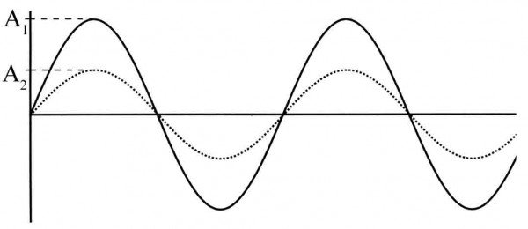
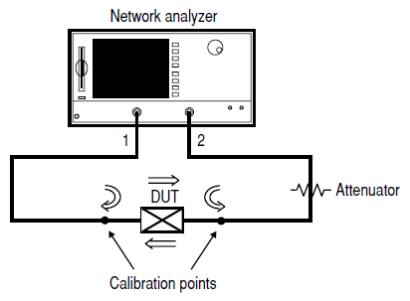
The diagram above depicts the network analyzer sending a sine wave into the equipment (DUT=Device under test), and then receiving a frequency response.
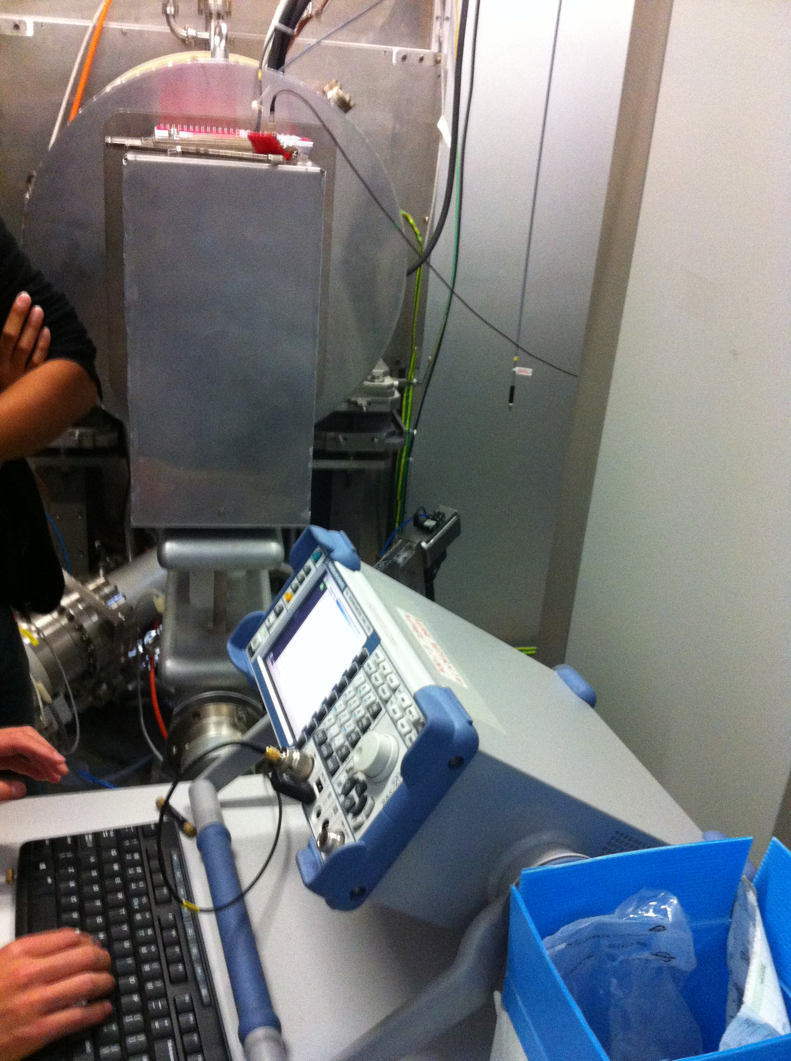The network analyzer in action
How to use the Network Analyzer (Various commands and tips)
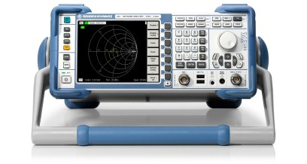
-To select S parameter, click preset button.
-To return to desktop, either click exit firmware (under Nwa file), or click the bottom of the screen, which shows the toolbar.
-To minimize the LAN status indicator, go to task manager and choose minimize.
-To run program, find external tools located in the nwa setup tab
-When attempting to modify a program, return to the desktop, click my computer, and then search for .vbs files.
-One can also find these programs by following this address -> C:\R_S\Instr\user\Nwa\External Tools.
-One must open these programs in notepad, to modify.
-To find center frequency or resonance, one may click the center button.
-To change the span frequency, click the span button.
-To set a marker, on a certain point click the marker button.
-----http://cdn.rohde-schwarz.com/dl_downloads/dl_common_library/dl_manuals/gb_1/z/zvl_1/ZVL_Operating_008_V3_20.pdf
How to measure Quality factor on the Network Analyzer

Conclusion

Over my two week at CERN, I have had a great experience. In the mornings I have attended lectures that are for the CERN summer students. These lectures were very hard to follow, as my boss Olav Berrig said, “you will understand close to nothing.” But by the end of two weeks, I was able to put my fundamental physics knowledge (mass, velocity, frequency, wavelength, etc.) to use by helping me to understand some topics that were talked about. In the afternoons I have worked with Olav. During the first week I found out what a network analyzer does, as well as how it works. We attempted to program the network analyzer, but the process would have taken many more days then we were allotted to take. So in the second week we worked with two Japanese university students, who were in fact also using the network analyzer. They were trying to simulate Hydrogen plasma in a proton beam. The two of them needed our help to solve Q factor. Over the course of the week we helped them, and it was a success. Overall, I viewed my traineeship this summer as a great opportunity and learning experience. Not many people get to travel to Europe, much less work at the most prestigious particle physics laboratory in the world-which is CERN. I learned many great things over these two weeks, and I am very happy I had this experience.

